Contingency Tables

#1

#2

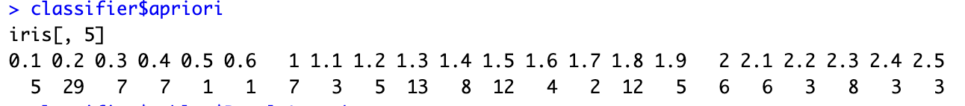

#3

#4

#5

#6

#7

#8

